1. Windows Instance :

1) Windows Instance Launch Status:

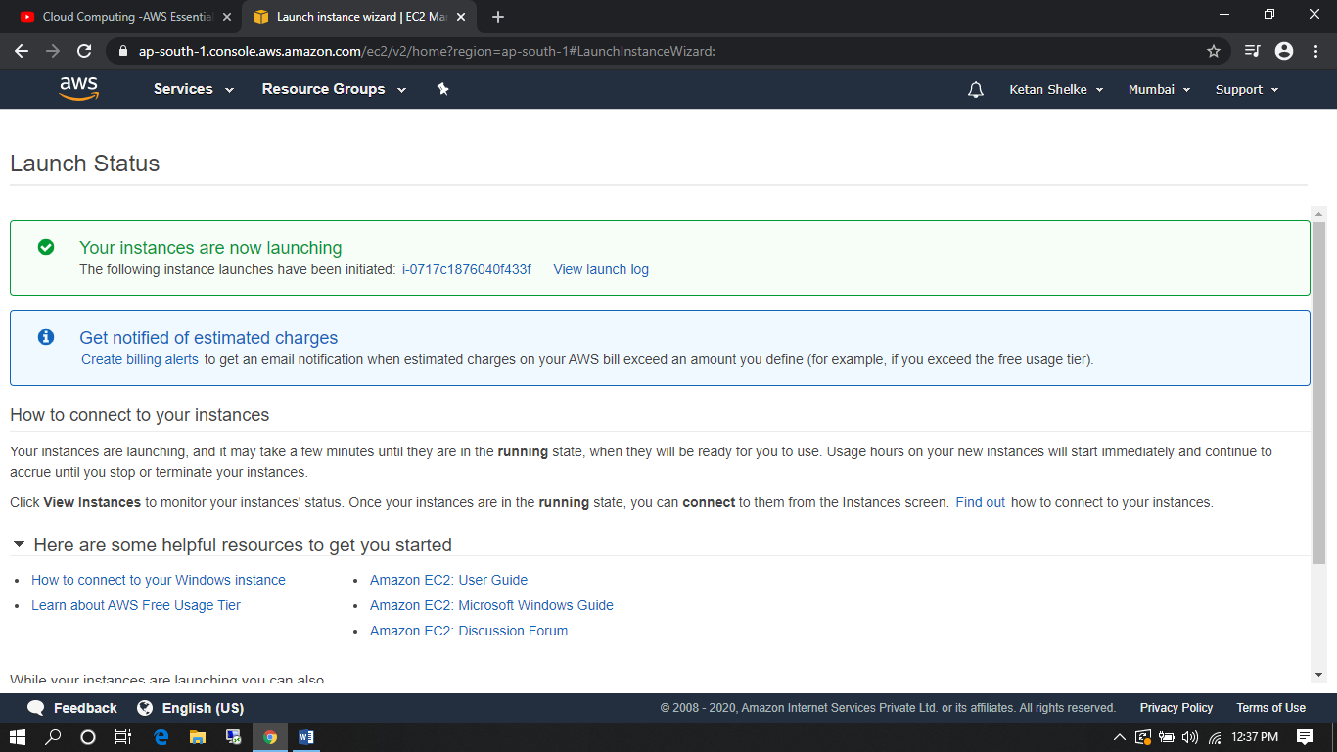

1. Windows Launch Instance :

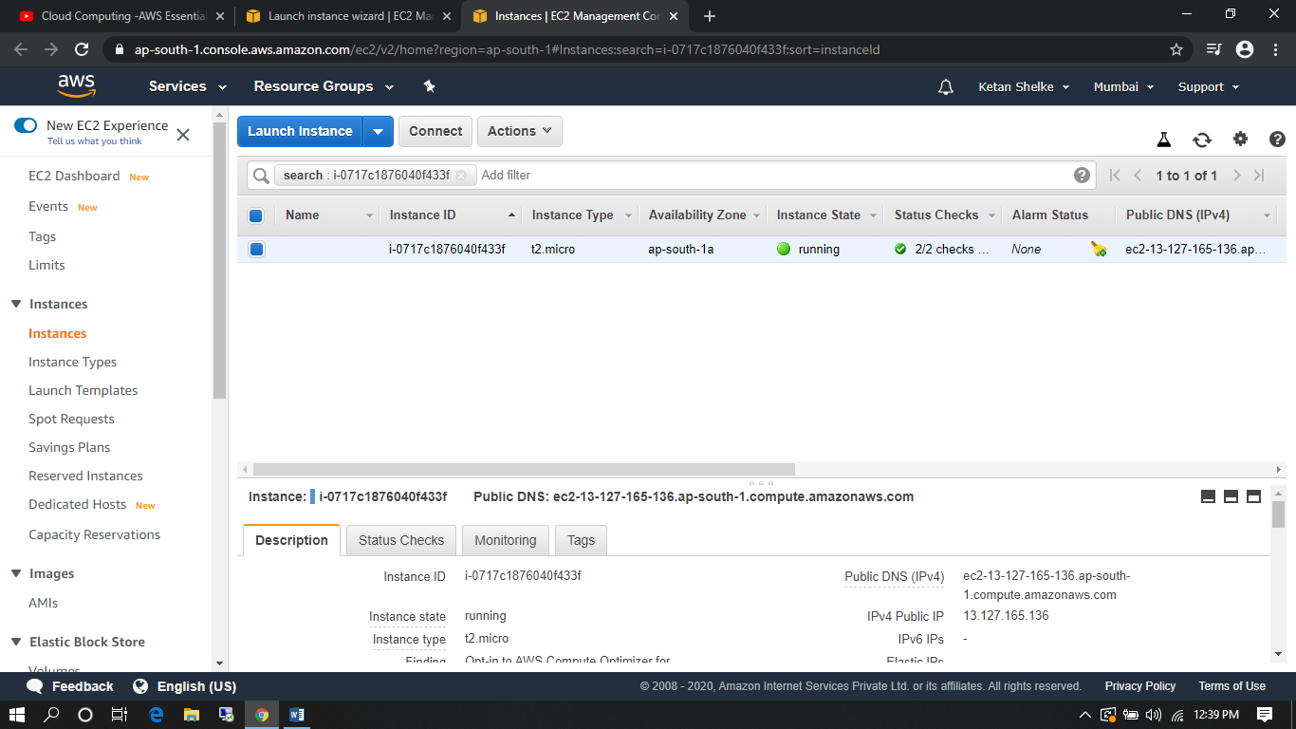

3) Created Windows Machine:

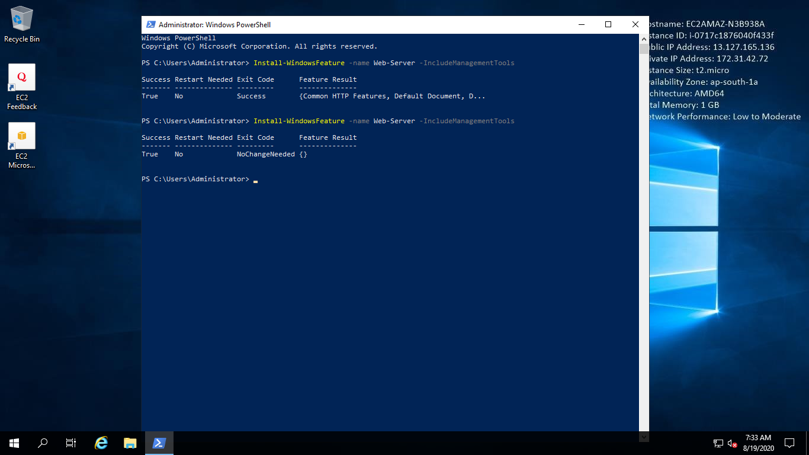

4) Final Windows Server (13.127.165.136):

